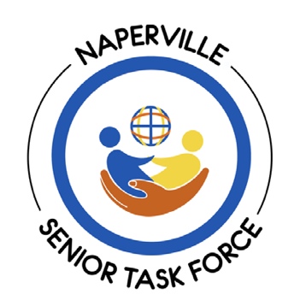
Application to Serve on
The Senior Task Force

Thank you for your interest in serving on the Senior Task Force. The volunteer spirit of Naperville is an essential part of what makes this city so wonderful.

Name___________________________________________________________ Date _________________
Home Address_____________________________________________________________________
City________________________________ State__________ Zip Code____________
Home Phone __________________________________ Work or Cell Phone ___________________
E-mail Address___________________________________________________________
How long have you been a resident of Naperville or the surrounding communities? ____________________________

In a few sentences, describe why you are interested in serving on the Senior Task Force:

List any relevant experience you may have that would enhance your service on the Senior Task Force (e.g. commissions, committees, volunteering, participation in other charitable organizations, or other interests you have that would assist on the Senior Task Force):

What skills do you have that could further the work of the task force? For example: newsletter writing and/or editing, public speaking/presentations, social media knowledge and expertise:

Is your personal schedule conducive to attending in person monthly meetings, joining task force committees, and representing the task force at community events and activities?

Please return the completed application and a copy of your resume/CV to:
Gwenn Lloyd
1038 Colonial Court
Naperville, IL 60540
Or via email to:
gwennhlloyd@gmail.com
For more information, or if you have any questions, please contact Senior Task Force Chair Gwenn Lloyd at 630-207-0586.
Revised 3/23/26

