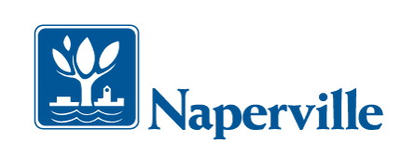

## **N O T I C E**

Inspection crews will be conducting a physical survey of the **City of Naperville** sanitary sewer system in your area. Workers will be accessing manholes to “SMOKE TEST” sewers and locate defects in the system. The smoke is NON-TOXIC, HARMLESS AND CREATES NO FIRE HAZARD.

The smoke should not enter your home unless you have defective plumbing or dried up drain traps. Pour 1 gallon of water down all floor drains and any rarely used sinks/ tubs/ toilets to ensure a water barrier is maintained in the drain traps. The drain trap water barrier is there to prevent sewer gases or odors from entering the building. If the drain trap water barrier is present and smoke does enter your home, the potential exists for sewer gases to also enter your home and you should consult a licensed plumber to fix the problem.

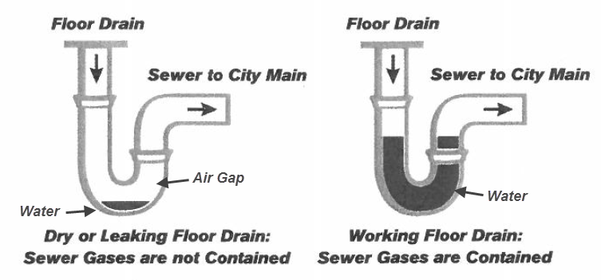

Some sewer lines and manholes may be located in backyards. Whenever these lines require investigation, members of the inspection crews will need access to the sewer lines and manholes. These crews are RJN Group personnel and will be identified with uniforms and badges. Homeowners do not need to be home and **FIELD CREWS ARE NOT REQUIRED TO ENTER YOUR BUSINESS OR RESIDENCE.**

**If smoke enters your home, and the field crew is still on your street, please contact a member of the crew or the RJN Field Crew Leader at (630) 639-1914.**

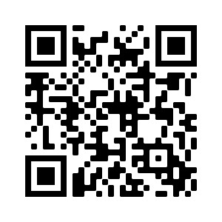The information gained from this study will be used to improve the sewer system in keeping with state and federal regulations. **Please call if you have any questions about respiratory concerns or the smoke testing process, RJN staff will be happy to help you.**

**For additional information:**

[**www.rjn.com/faq**](http://www.rjn.com/faq)

**www.Naperville.il.us/smoketest**

**Call - City of Naperville, Dpt. of Public Utilities – Jeffrey Burger – (630) 305-6202**

**RJN Project Manager, Karol Giokas –   
(630) 682-4700 x1386**