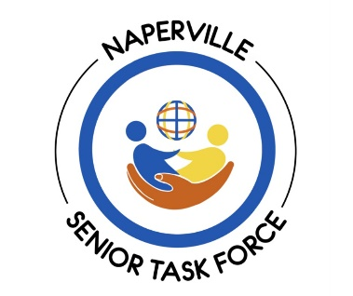

Naperville Senior of the Year

2025 Nomination Form

Complete this form to nominate a senior you think deserves to be recognized as Naperville’s 2025 Senior of the Year. One female and one male will be selected for an award. The winners will be announced during the Naperville City Council meeting on Tuesday, October 7, 2025. Submit this form to: Senior Task Force member Bonnie Hilton at nominateasenior@gmail.com

Eligibility Criteria
- Nominee must be age 65 years or older and a current Naperville resident
- Nominations must be received no later than Sunday, August 31, 2025

Nominee
Name ___________________________________________________ Age _________
Address ____________________________________________________________________
Phone _____________________________ Email _____________________________

Nominated By
Name ___________________________________________________
Address ____________________________________________________________________
Phone _____________________________ Email _____________________________

Reason for Nominating
Below, describe why the nominee deserves the Senior of the Year award. Be sure to include the nominee’s volunteer and community activities as well as information about their background, career or family. Include the names, years and positions held in civic and charitable organizations. You may include news articles about the nominee and letters of support from other people.

